14/11/20
THM 121 Business Mathematics
Midterm Exam Answer Sheet
Note to the students:
- Calculations to reach your answers shall be thoroughly shown. Otherwise, questions will NOT be graded.
- You can use a calculator throughout the exam.
- Factor and simplify the given expression as much as possible: (2 Points)
2χ + 3y + χy + 6
2χ + 3y + χy + 6 = 2(χ) + 2(3) + 3(y) + χ(y) = 2(χ + 3) + y(χ + 3) = (χ + 3) (y + 2).
- Factor and simplify the given rational expression: (2 Points)
(a² – 7a – 30) / (a² – 5a – 24)
a² – 7a – 30) / (a² – 5a – 24) = [(a + 3) (a – 10)] / [(a + 3) (a – 8)]. Assuming that a ≠ - 3, we can divide each of the numerator and the denominator by (a + 3) and hence get (a – 10) / (a – 8).

- Factor the given polynomial using integer coefficients: (2 Points)
4χ³ - 3χ² - 10χ
4χ³ - 3χ² - 10χ = χ (4χ² - 3χ – 10) = χ (4χ + 5) (χ – 2).
- Solve the following quadratic equation by completing the square: (2 Points)
2χ² + 7χ - 15 = 0
2χ² + 7χ - 15 = 0 ↔ χ² + (7/2)χ – (15/2) = 0 ↔ χ² + (7/2)χ = (15/2) ↔ χ² + (7/2)χ + (7/4)² = (15/2) + (7/4)² ↔ (χ + 7/4)² = (120/16) + (49/16) ↔ (χ + 7/4)² = (169/16) ↔ (χ + 7/4)² = (13/4)² ↔ either χ + 7/4 = 13/4 or χ + 7/4 = -13/4 ↔ χ = 3/2 or χ = -5.
- Use the quadratic formula to solve the following equation: (2 Points)
3ϳ² + 7j - 5 = 0
3ϳ² + 7j - 5 = 0; ∆ = (7)² – 4 (3) (-5) = 49 + 60 = 109 ↔ = .Therefore, there are 2 solutions for this quadratic equation:
Either j = (-7 + ) / 6 or j = (- 7 - ) / 6.
- Solve the given system of equations: (3 Points)
3χ + 4y = 10 AND 2 χ + 3y = 7
3χ + 4y = 10 (i) and 2 χ + 3y = 7 (ii)
(ii) → χ = (-3y + 7) / 2.
Substituting the value of χ into equation (i), we get: 3 (-3/2y + 7/2) + 4y = 10 ↔ (-9/2)y + 4y + 21/2 = 10 ↔ (-1/2)y = -1/2 ↔ y = 1. If y = 1 then χ = [(-3 * 1) + 7) / 2 = 2.
- Evaluate the given sum: (2 Points)
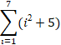
= (1² + 5) + (2² + 5) + (3² + 5) + (4² + 5) + (5² + 5) + (6² + 5) + (7² + 5) = 6 + 9 + 14 + 21 + 30 + 41 + 54 = 175.
- Express the given sum in terms of summation notation: (2 Points)
2 + 5 + 8 + 11
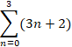
Or
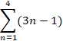
- Find the composite function (g o h) (χ) where: (2 Points)
g (χ) = -6χ + 5 and h (χ) = -9χ - 11
(g o h) (χ) = g (-9χ – 11) = -6 [-9χ - 11] + 5 = 54χ + 66 + 5 = 54 χ + 71.
- It is estimated that t years from now, the population of a certain suburban community will be:
P (t) = 30 – [(7) / (t + 2)] (in thousand people)

- What will be the population of the community 8 years from now? (1 Point)
P (8) = 30 – [7 / (8 + 2)] = 30 – (7/10) = 30 – 0.70 = 29.30.
Therefore, the population of the community 8 years from now will be 29,300 people.
b) By how much will the population increase during the 8th year? (1 Point)
P (8) – P (7) = 29.30 – [30 – [7 / (7 + 2)]] = 29.30 – [30 – (7/9)] = 29.30 – 30 + (7/9) = - (7/10) + (7/9) = - (63/90) + (70 / 90) = 7/90.
Therefore the population will increase by 1,000 * (7/90) (i.e. 77.78 people) during the 8th year.
c) What happens to P (t) as t gets larger and larger? (1 Point)
As t gets larger and larger, the population P (t) gets towards 30,000 people.
- Suppose χ = -300p + 15000 units of a particular commodity are sold each month when the market price is p dollars per unit. The total monthly consumer expenditure E is the total amount of money spent by consumers during each month.
- Express the total monthly consumer expenditure E as a function of the unit price p. (1 Point)
E (p) = p * (-300p + 15000) = -300p² + 15000p.
- Sketch the graph of E (p). (3 Points)
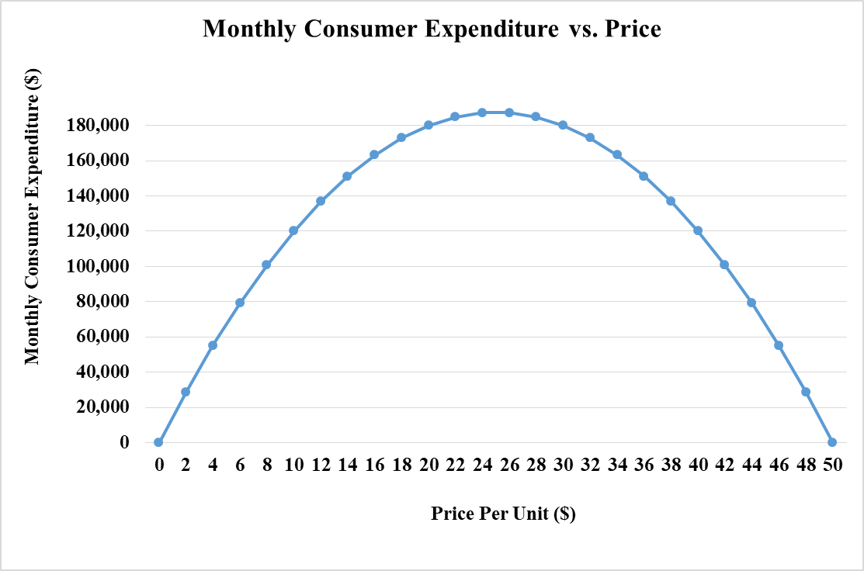
- Discuss the economic significance of the p intercepts of the expenditure function E (p). (2 Points)
The p intercepts represent prices at which consumers spend no money on the commodity.
- Inspired from the the graph plotted in part b), determine the market price p that generates the greatest total monthly consumer expenditure. (1 Point)
Referring to the graph plotted in part b), the market price p that generates the greatest total monthly consumer expenditure is $ 25 per unit.
- A pay-as-you-go cell phone company offers a monthly plan for $ 25 that includes 400 minutes of calls. After that, calls are charged for 8 cents per minute up to a maximum of 800 minutes. Any call exceeding 800 minutes is charged at 3 cents per minute up to 1,500 minutes. Let C (m) be the cost in dollars of making m minutes of calls with a phone on this plan, for 0 ≤ m ≤ 1,500
- Write C (m) as a piecewise-defined function. (1 Point)
C (m) = 25 if 0 ≤ m ≤ 400
C (m) = 25 + 0.08 (m – 400) if 400 < m ≤ 800
C (m) = 57 + 0.03 (m – 800) if 800 < m ≤ 1500
- Sketch the graph of C (m). (3 Points)
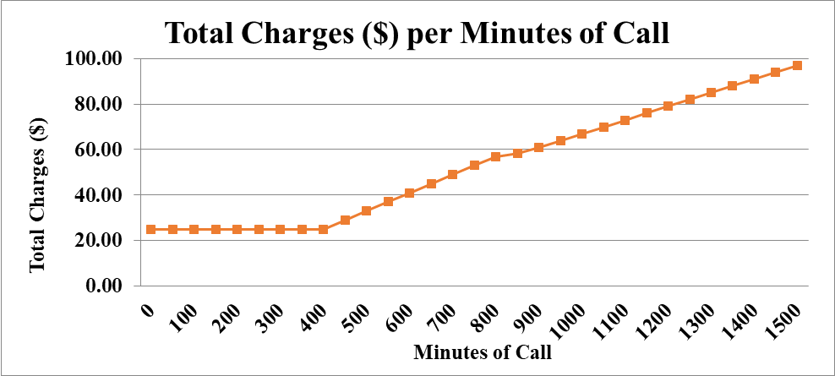
GOOD LUCK!

